**UNIT 1 – OPERATIVE SYSTEMS INSTALATION EXERCISES**

1. Create an empty virtual machine and configure the following settings:
   * For Windows 10 (64 bits, or 32 if you do not have enough RAM in your physical computer).
   * 2GB of RAM memory.
   * Boot order (CD and hard drive).
   * Two hard drives: one with 50 GB for the operating system and another one with 30 GB empty. Select the type of disk that can dynamically increase.

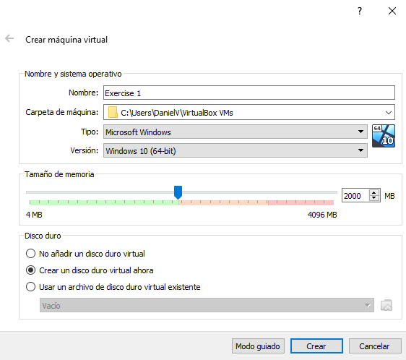

First, we create a new virtual machine. Then, choose the operative system, the memory RAM (2GB) size and the first hard drive for the operative system.

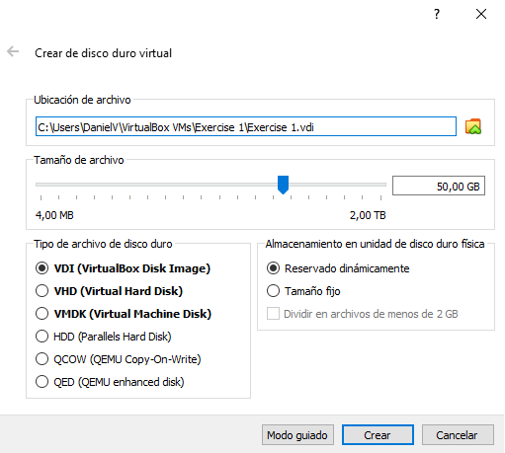

Then, we select the hard disk size,

In this case with 50GB.

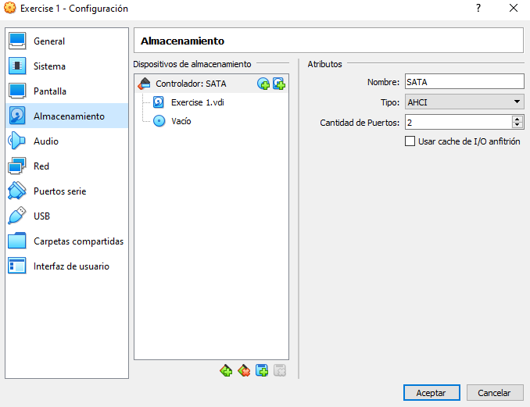Next, we click in “Configuration” and then:

2

1. Go to “storage”.

1

1. Click in the hard drive icon.
2. Create a new hard disk.
3. Select the type of hard disk (Virtual Hard Disk) and select “dynamically allocated”.
4. Finally, we select the hard disk size, 30GB in this case.

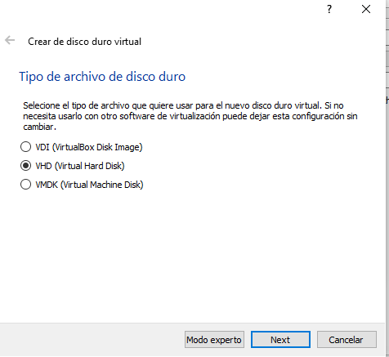

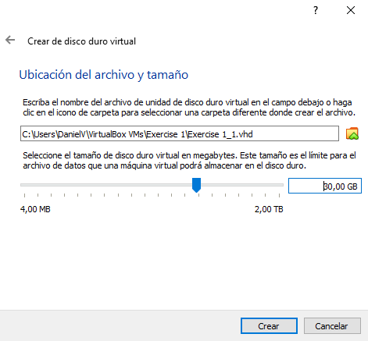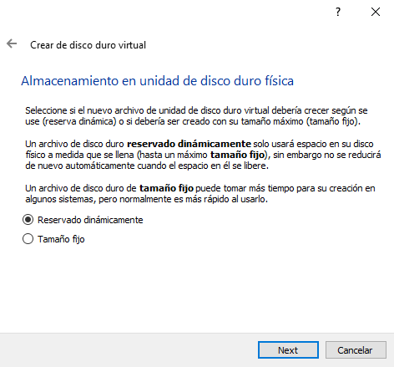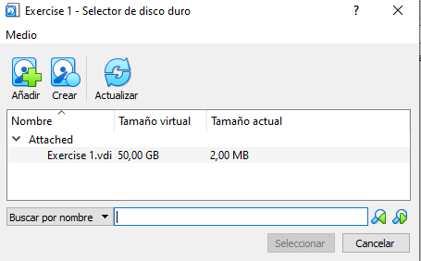

3

4

4 5

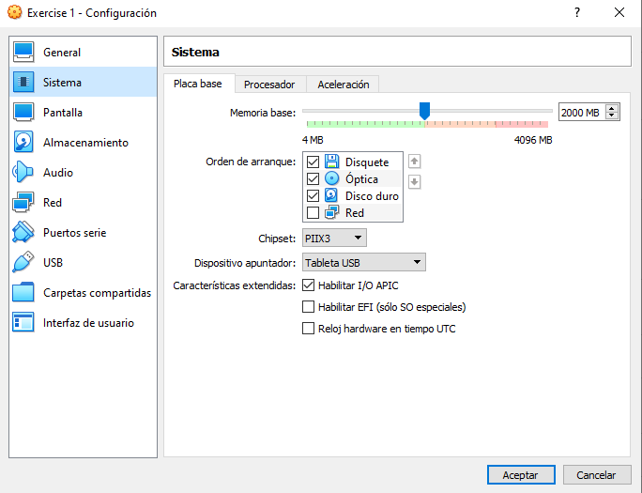

Afterwards, to choose the boot order, we have to go to “System” in Configuration:

First the CD and then the hard drive.

After all, this is the general sight.

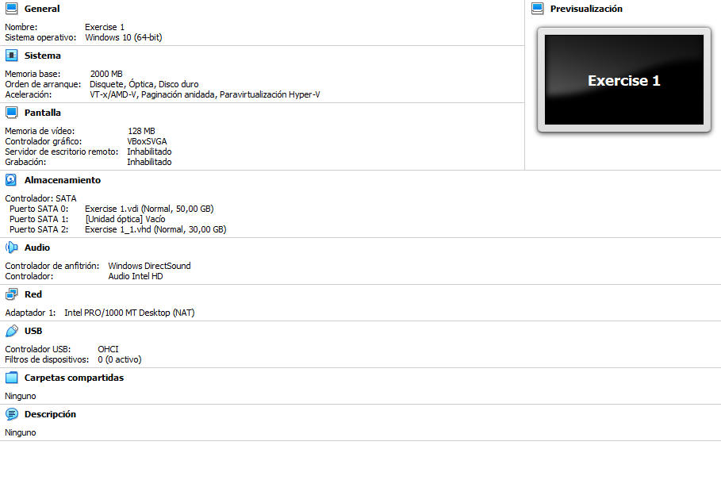

1. Install Windows 10 in the virtual machine from exercise 1. You must add the following settings:
   * USB 3.0 support.
   * Shared folders.
   * Internet connection including access to the rest of computers of the network.
   * You will be able to copy and paste from the host to the guest and vice versa.

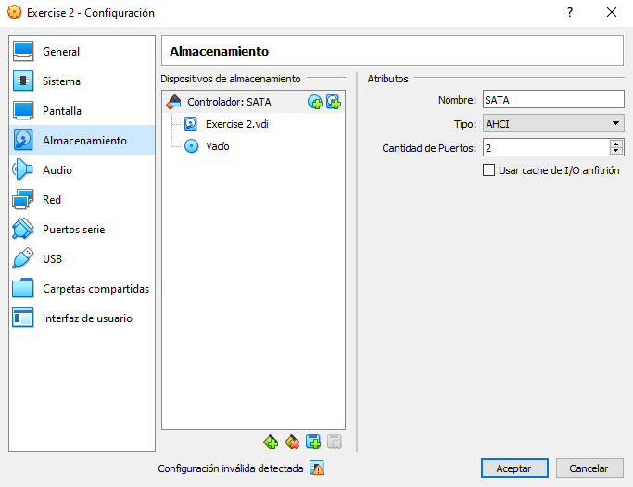

1

In first place, we go to “storage” in

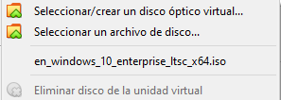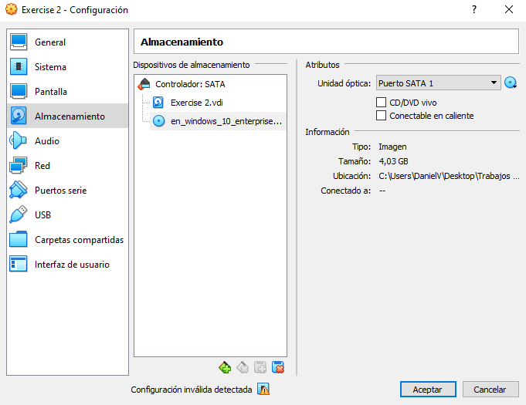Settings, click in the empty disk, then, go to “select a disk file”

3

2

